Debezium

建置一個 Debezium Connector 搭配 Kafka & Postgre SQL

- 執行以下指令建立 Docker 容器 (如附檔，docker-compose.yml )
docker-compose up -d

- 看到以下即建置成功


- 建立SQL 與 Kafka 的連結
- 建立表及 Publication
- 進入 Postgre SQL 建立以下表 (Orders)
CREATE TABLE orders (
id SERIAL PRIMARY KEY,
name VARCHAR(50)
);

- 建立 publication
CREATE PUBLICATION dbz_publication FOR ALL TABLES;
這個 publication 會包含「現在以及未來建立的所有 table」
CREATE PUBLICATION dbz_publication FOR TABLE {TableName}
以上是為特定表建立 publication

- 建立 Debezium Connector
建立 postgres-connector.json
註. 這是Debezium 在 Apache Kafka Connect 上註冊的 Connector 設定，用途是把 DB transaction log 轉成 Kafka event。
{
"name": "postgres-connector",
"config": {
"connector.class": "io.debezium.connector.postgresql.PostgresConnector",
"database.hostname": "postgres",
"database.port": "5432",
"database.user": "postgres",
"database.password": "postgres",
"database.dbname": "demo",
"topic.prefix": "postgres",
"plugin.name": "pgoutput",
"publication.name": "dbz_publication",
"slot.name": "debezium_slot"
}
}

執行以下指令進行註冊：
curl -X POST http://localhost:8083/connectors -H "Content-Type: application/json" -d @postgres-connector.json

- 測試 CDC
在 Postgre SQL 插入一筆資料
INSERT INTO orders(name) VALUES ('order1');

- 查看Kafka 確認是否連接成功
打開 Kafka UI，找到以下 Topic
postgres.public.orders
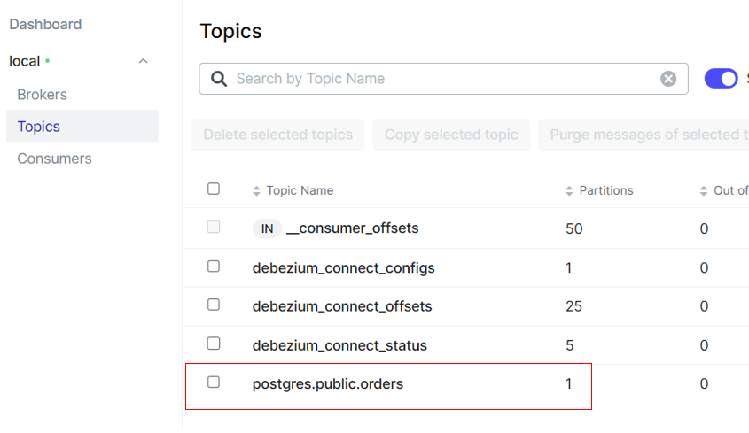
看到以下 Message，代表與 Kafka連接成功
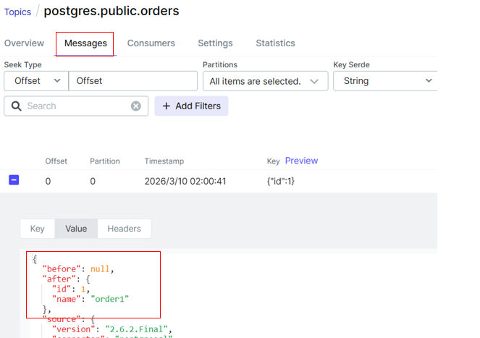

整個 CDC 架構
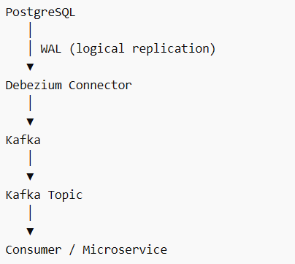

- 附檔:
services:

kafka:
image: confluentinc/cp-kafka:7.5.0
container_name: kafka
ports:
- "9092:9092"
environment:

KAFKA_NODE_ID: 1
KAFKA_PROCESS_ROLES: broker,controller

KAFKA_LISTENERS: PLAINTEXT://0.0.0.0:9092,CONTROLLER://0.0.0.0:9093
KAFKA_ADVERTISED_LISTENERS: PLAINTEXT://kafka:9092

KAFKA_CONTROLLER_LISTENER_NAMES: CONTROLLER
KAFKA_LISTENER_SECURITY_PROTOCOL_MAP: CONTROLLER:PLAINTEXT,PLAINTEXT:PLAINTEXT

KAFKA_CONTROLLER_QUORUM_VOTERS: 1@kafka:9093

KAFKA_OFFSETS_TOPIC_REPLICATION_FACTOR: 1
KAFKA_TRANSACTION_STATE_LOG_REPLICATION_FACTOR: 1
KAFKA_TRANSACTION_STATE_LOG_MIN_ISR: 1

KAFKA_GROUP_INITIAL_REBALANCE_DELAY_MS: 0

CLUSTER_ID: MkU3OEVBNTcwNTJENDM2Qk

postgres:
image: postgres:15
container_name: postgres
ports:
- "5432:5432"
environment:
POSTGRES_USER: postgres
POSTGRES_PASSWORD: postgres
POSTGRES_DB: demo
command:
- "postgres"
- "-c"
- "wal_level=logical"
- "-c"
- "max_wal_senders=10"
- "-c"
- "max_replication_slots=10"

connect:
image: debezium/connect:2.6
container_name: debezium-connect
depends_on:
- kafka
- postgres
ports:
- "8083:8083"
environment:

BOOTSTRAP_SERVERS: kafka:9092

GROUP_ID: 1

CONFIG_STORAGE_TOPIC: debezium_connect_configs
OFFSET_STORAGE_TOPIC: debezium_connect_offsets
STATUS_STORAGE_TOPIC: debezium_connect_status

CONNECT_KEY_CONVERTER: org.apache.kafka.connect.json.JsonConverter
CONNECT_VALUE_CONVERTER: org.apache.kafka.connect.json.JsonConverter

CONNECT_KEY_CONVERTER_SCHEMAS_ENABLE: "false"
CONNECT_VALUE_CONVERTER_SCHEMAS_ENABLE: "false"

kafka-ui:
image: provectuslabs/kafka-ui:latest
container_name: kafka-ui-1
depends_on:
- kafka
ports:
- "8028:8080"
environment:

KAFKA_CLUSTERS_0_NAME: local
KAFKA_CLUSTERS_0_BOOTSTRAPSERVERS: kafka:9092

